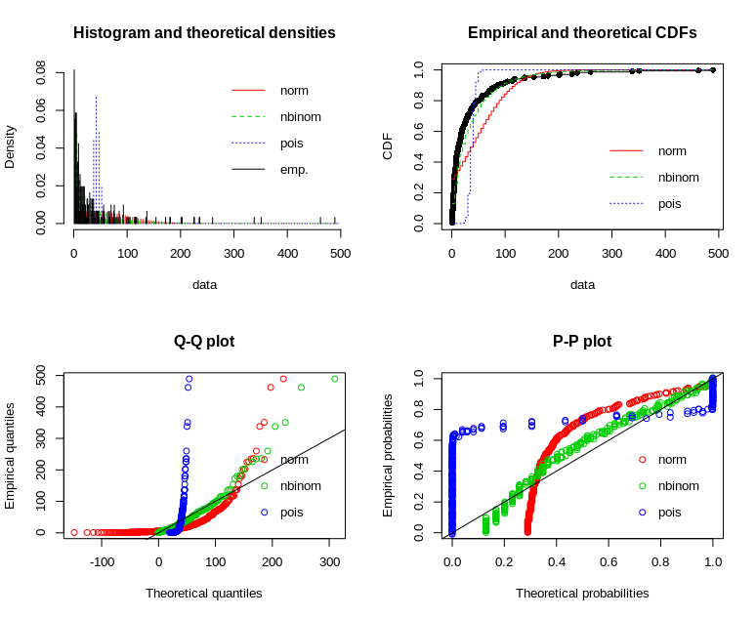
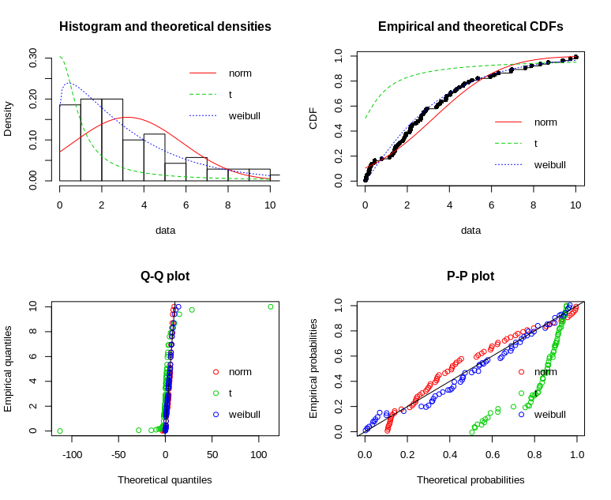

A. Pinworms B. Eimeria

Supplementary Figure S7. Choice of distribution for (positive) parasite loads (intensity).

